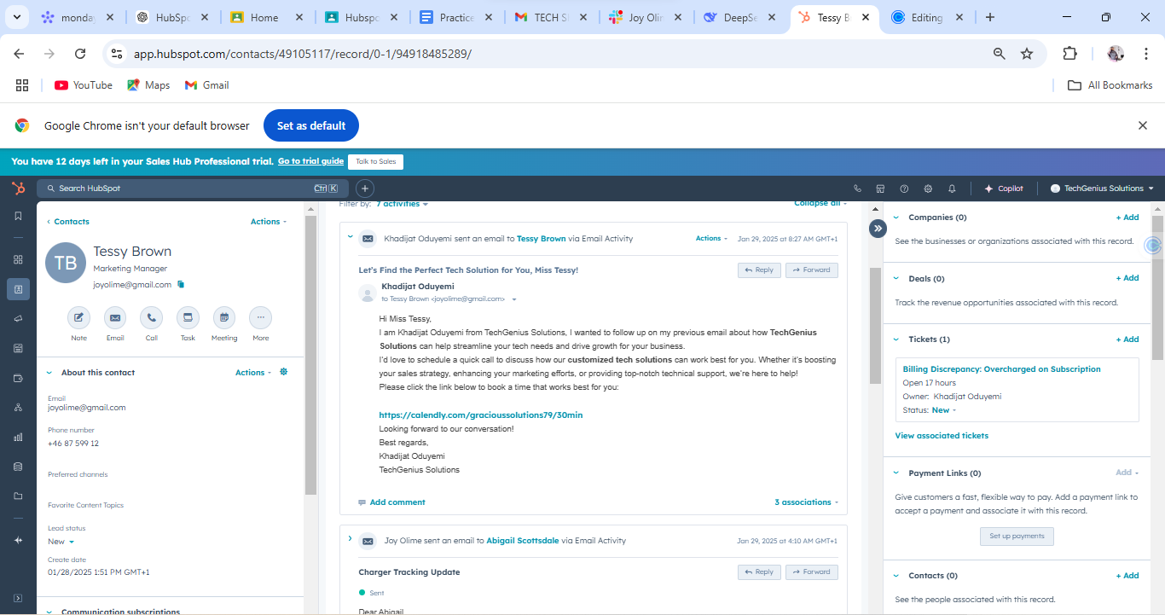

←

monday

**X**

HubSpc x Home X

Hubspc X

Practice XM TECH SI X

Joy Olin x

DeepSe X

Tessy B X

Editing X

→

Capp.hubspot.com/contacts/49105117/record/0-1/94918485289/

Q ✩

YouTube

Maps M Gmail

Google Chrome isn't your default browser

**Set as default**

**You have 12 days left in your Sales Hub Professional trial. Go to trial guide Talk to Sales**

Q Search HubSpot

ធ

< Contacts

Actions -

Tessy Brown

品

TB

Marketing Manager

A

joyolime@gmail.com

Note

Email

Call

Task Meeting

More

**About this contact**

Email

joyolime@gmail.com

Phone number

+46 87 599 12

Preferred channels

Favorite Content Topics

Lead status

New

Create date

01/28/2025 1:51 PM GMT+1

w

**Actions -**

Ctrl K

Filter by: 7 activities ▾

Collapse all-

Khadijat Oduyemi sent an email to Tessy Brown via Email Activity

Actions -

Jan 29, 2025 at 8:27 AM GMT+1

**Let's Find the Perfect Tech Solution for You, Miss Tessy!**

**Khadijat Oduyemi**

+ Reply

→Forward

0

All Bookmarks

X

Copilot

TechGenius Solutions

Companies (0)

**+ Add**

See the businesses or organizations associated with this record.

Deals (0)

**+ Add**

**+ Add**

to Tessy Brown <joyolime@gmail.com>▾

Hi Miss Tessy.

I am Khadijat Oduyemi from TechGenius Solutions, I wanted to follow up on my previous email about how TechGenius Solutions can help streamline your tech needs and drive growth for your business.

I'd love to schedule a quick call to discuss how our customized tech solutions can work best for you. Whether it's boosting your sales strategy, enhancing your marketing efforts, or providing top-notch technical support, we're here to help! Please click the link below to book a time that works best for you:

**https://calendly.com/gracioussolutions79/30min**

Looking forward to our conversation!

Best regards,

Khadijat Oduyemi

TechGenius Solutions

Track the revenue opportunities associated with this record.

Tickets (1)

**Billing Discrepancy: Overcharged on Subscription Open 17 hours**

Owner: Khadijat Oduyemi

Status: New

View associated tickets

**Payment Links (0)**

Add comment

3 associations -

Joy Olime sent an email to Abigail Scottsdale via Email Activity

Jan 29, 2025 at 4:10 AM GMT+1

Charger Tracking Update

**Sent**

Communication subscriptions.

**Dear Abigail**

← Reply

→Forward

Add-

Give customers a fast, flexible way to pay. Add a payment link to accept a payment and associate it with this record.

Set up payments

Contacts (0)

**+ Add**

See the people associated with this record.